**Task 2- Student Database Management System**

**1.Database Setup**

Create database student_database

create table Student_Table(

student_ID int Primary Key,

Stu_name text,

Department text,

Email_ID text,

Phone_no numeric,

Address text,

Date_of_birth date,

Gender text,

Major text,

GPA numeric,

Grade text);

**2. Data Entry**

Insert into student_table values

(201,'Gaurav','CSE','gaur@amazon.com',8973772165,'Bangalore', '06-07-1994','M','CS',7.9,'C'),

(202,'Abha','CSE','abha@amazon.com',9873772165,'Patna', '07-06-1994','F','Physics',8.0,'C'),

(203,'Ram','ECE','ram@amazon.com',6773882165,'Madhurai', '07-06-1994','M','IT',9.3,'A'),

(204,'Raju','EEE','raju@amazon.com',9073723165,'Chandigarh', '07-06-1994','M','Biology',9.7,'A'),

(205,'Shiva','MECH','shiva@amazon.com',6773778165,'Shimla', '07-06-1994','M','Botny',8.1,'B'),

(206,'Manu','ECE','manu@amazon.com',8873232165,'Chennai', '07-06-1994','M','Zoology',8.7,'B'),

(207,'Gaba','IT','gaba@amazon.com',9973777865,'Chennai', '07-06-1994','F','Maths',8.3,'B'),

(208,'Hero','IT','hero@amazon.com',9073723165,'Chennai', '07-06-1994','M','Maths',8.9,'B'),

(209,'Aisha','CIVIL','aisha@amazon.com',9823772165,'Ranchi', '07-06-1994','F','Philosophy',9.5,'A'),

(210,'Anwar','CIVIL','anwar@amazon.com',9973782165,'Kanpur', '07-06-1994','M','History',9.6,'A');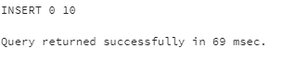

**3.Student Information Retrieval**

**Query to retrieve student information and sort based on descending grade**

select * from student_table

order by Grade DESC;

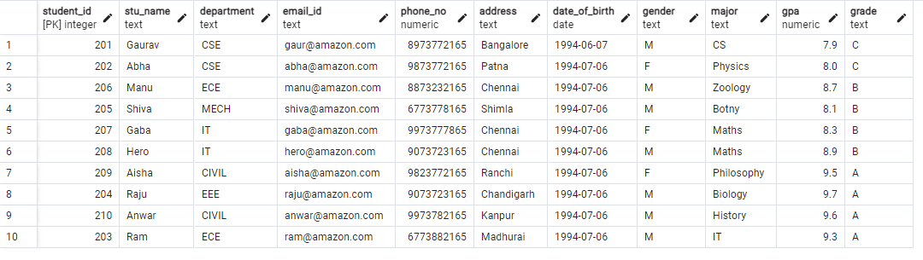

**4. Query for male students**

Select * from student_table

where gender='M';

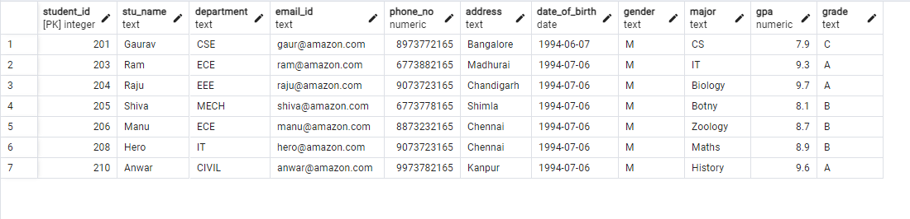

**5. Query for students with GPA less than 5.0**

select * from student_table

where gpa<5.0;



**6. Update student email and grade**

update student_table set email_id='gunja@amazon.com',grade='E' where stu_name='Raju';

**7. Query for students with grade “B”**

Select stu_name, Age(now(),date_of_birth)as age from student_table where grade='B';

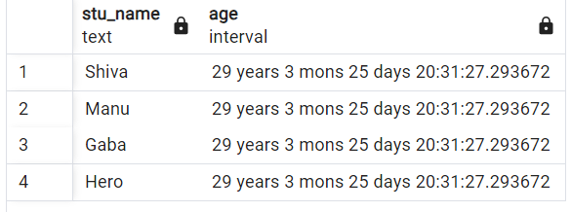

**8. Grouping and calculation**

Select department,gender,AVG(gpa) as average_gpa from student_table

group by department,gender;

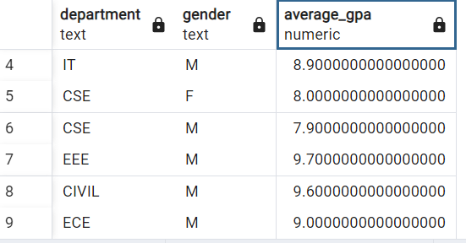

**9. Table Renaming**

Alter table student_table rename to student_info;

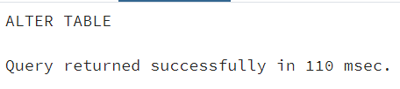

**10. Retrieve students with Highest GPA**

select stu_name from student_info where gpa=(select max(gpa)from student_info);

